THE VINATGE TWIN Test Scenario
- We added 2 product in shopify and enter the same sku's in both product. Then back to vintagetwin app and add new batch with same sku and submit . Cron the URL and click on run process button and check at that time both products updated or not in shopify.
- We Click on multiple time Add batch button and check below single single batch added or not.
- Click on delete batch and check whether the separate batch is getting deleted or multiple batches are getting deleted in one.
- Once the name of the batch is entered, it remains fixed or is removed, it is checked.
- When you leave the batch or close the window and open it again, it stays in the same position or not.
- In batch history, select batch and click on delete batch and check whether it is being deleted or not.
- Checking whether the tag is being removed by writing the name capitalization in the remove tag in the batch.
- When we click on a batch, the batch history appears highlighted but when we click on the batch history, the batch also appears highlighted.

Some design points
- In mobile view design break
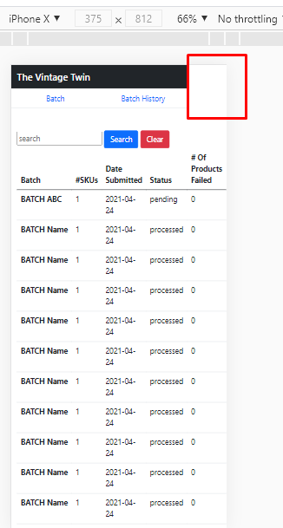

- Smallest UI Changes

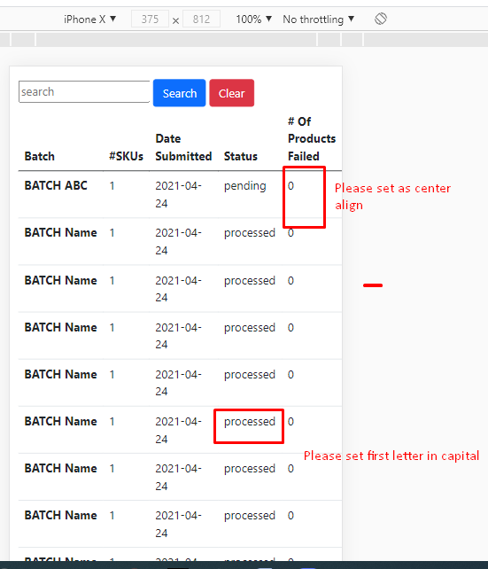

3.
